Investing Across Borders What Are You Actually Buying

Part 1 of 3 ETFs, Irish UCITS, currency exposure, and the cost of ownership
Imagine three Kenyan siblings comparing their investments during a Sunday call. Amina lives in Nairobi, Brian works in Manchester, and Catherine has recently moved to Dublin. All three want to own a slice of the companies shaping the global economy. They have found exchange-traded funds, discovered that Irish funds can hold American shares, and heard that accumulating dividends makes investing more efficient. Their conversation soon turns into a competition between ticker symbols. Yet the most useful question comes before the ticker: what exactly will each person own, through which legal structure, and for which future expense? These siblings are fictional, and the calculations throughout this series are illustrations. Their situation provides a practical way to explore a real problem: the same investment can produce different outcomes when its owner, tax residence, spending currency, or route for moving money changes.
Start with the household rather than the brokerage screen. Amina earns shillings and expects most near-term expenses in Kenya. Brian earns pounds, helps his parents with medical costs, and may eventually return home. Catherine earns euros but has no settled retirement destination. Their investment horizons overlap, while their immediate commitments differ. Research on consumption and portfolio choice shows why labour income, borrowing constraints, and the stage of life belong in the investment decision alongside financial assets [1]. The practical interpretation here is straightforward: a portfolio must coexist with rent, unstable earnings, family support, and relocation costs. An investor who needs cash during a market decline may have little opportunity to benefit from a long investment horizon written in a spreadsheet. Before comparing funds, each sibling therefore separates money needed soon from money that can remain invested through an uncomfortable period.
International diversification becomes more meaningful when viewed against this wider household balance sheet. Someone with employment, a business, property, and retirement savings tied to Kenya already has substantial exposure to the Kenyan economy, even before buying local shares. French and Poterba documented strong domestic concentration in investors’ equity holdings in their influential study of international diversification [2]. Their historical findings do not prescribe today’s ideal allocation for a Kenyan household, but they invite a useful question: how many existing risks would an overseas investment genuinely diversify? Replacing every local asset with American technology shares simply introduces another concentration. A more considered approach examines countries, industries, employers, currencies, and sources of income together. Brian can remain committed to supporting his family in Kenya while building investments whose fortunes depend on a broader set of businesses and economic conditions.

Separate the five identities of a fund
An ETF has several identities that are easy to collapse into one. Its underlying investments determine economic exposure; its domicile identifies the jurisdiction of the fund; its exchange listing determines where a particular trading line changes hands; its trading currency determines the currency used for that transaction; and its share class determines features such as accumulation or distribution. Vanguard’s Irish S&P 500 accumulating ETF provides a concrete example: the July 2026 factsheet identifies Ireland as domicile, a physical investment method, and ISIN IE00BFMXXD54, with a dollar trading line called VUAA and a sterling London line called VUAG [3]. The different tickers do not create different underlying national economies. Recording the ISIN alongside the exchange and trading currency helps the siblings compare the actual investment, particularly when different platforms display different names for the same share class.
The ETF itself is a pooled investment whose shares trade on an exchange. For the ordinary investor, buying a share normally means transacting in that exchange market, while the fund owns or obtains exposure to a portfolio underneath. The price available on the screen can differ from the value of the underlying assets per share, and buying and selling involve a bid–ask spread [4]. That distinction matters because an attractive fund can still be purchased at an unattractive execution price. It also explains why the number of fund shares is a poor measure of diversification. Ten shares in one broad fund can represent exposure to many businesses; ten different funds can repeatedly own the same businesses. Amina’s useful unit of analysis is therefore the underlying portfolio and its role in her finances, followed by the practical terms on which she can acquire it.
The word “global” deserves similar inspection. An S&P 500 fund holds large American companies, many of which sell around the world, but overseas revenue does not turn the index into a complete global equity portfolio. A broader international fund can add companies listed in other markets, while an emerging-market fund introduces a different mix again. These are choices about exposure, rather than a hierarchy in which the longest fund name wins. Consider a deliberately simplified portfolio with 80% in a broad American index and 20% in a technology fund. If a particular company represents 6% of the first fund and 12% of the second, its combined portfolio weight is 7.2%. The extra fund has increased that company’s importance. This small calculation is often more revealing than counting how many products appear in the account.

Worked calculation 1 Looking through overlapping funds
Combined company weight = sum of (fund allocation × company weight in fund)
= (0.80 × 0.06) + (0.20 × 0.12)
= 0.048 + 0.024
= 0.072 = 7.2%
On a $10,000 portfolio: $10,000 × 0.072 = $720 of company exposure.
All weights in this example are hypothetical.

A currency label is only the beginning
Currency becomes easier to understand when the direction of the exchange rate is explicit. Suppose Amina invests the equivalent of $10,000 when one dollar costs KES 130. Her starting commitment is KES 1,300,000. The investment then rises by 8% in dollars, but the dollar later buys only KES 120. Her dollar balance has grown to $10,800, while its shilling value has fallen slightly to KES 1,296,000. Buying a sterling trading line of the same unhedged underlying portfolio would not automatically remove this economic issue. The listing currency can influence conversion convenience, but the assets and any explicit currency hedge determine the exposure. For a household planning a shilling expense, measuring only the dollar return leaves out an essential part of the result. The calculation below deliberately excludes dealing charges and taxes so that the currency effect remains visible.

Worked calculation 2 Translating an investment into shillings
Let S₀ and S₁ be the starting and ending rates in KES per USD; R is the dollar investment return.
KES return = (1 + R) × (S₁ ÷ S₀) − 1
Starting value = $10,000 × 130 = KES 1,300,000
Ending dollars = $10,000 × 1.08 = $10,800
Ending shillings = $10,800 × 120 = KES 1,296,000
KES return = 1.08 × (120 ÷ 130) − 1
= −0.003076923 = −0.3077%
Alternative exchange-rate outcome, S₁ = 145:
Ending shillings = $10,800 × 145 = KES 1,566,000
KES return = (1,566,000 ÷ 1,300,000) − 1 = 20.4615%
The alternative outcome shows why currency should enter planning without becoming a prediction contest. If the dollar instead buys KES 145, the same investment gain produces a much larger shilling return. Neither scenario establishes where the exchange rate will go. Together they demonstrate that the investment and the currency can reinforce or offset each other. Brian’s retirement plan may involve both pounds and shillings, so a single reporting currency will never describe every future purchase perfectly. He can estimate the currency of his nearer commitments and keep an appropriate reserve, while allowing longer-term assets to serve broader objectives. A currency-hedged share class introduces another decision involving the hedge’s design and costs. The useful starting point is to identify the spending obligation, then understand the exposure, rather than assuming that an account displayed in pounds has become economically insulated from other currencies.

Follow the dividend through the structure
Irish UCITS discussions often begin with the phrase “tax efficient,” which is useful only after identifying whose tax is being discussed. Irish Revenue describes a gross roll-up regime under which an investment undertaking is generally exempt from Irish tax on profits earned for its investors [5]. That is a statement about the fund’s Irish treatment. It does not erase taxes withheld by countries where the underlying companies operate, nor does it settle the investor’s personal liability. Think of a dividend travelling through successive stages: company, fund, investor, and the investor’s tax return. A deduction at one stage may already be embedded in the fund’s value before the investor receives any statement. This is the substance of the “in situ” question in the source notes: identify what happens inside the investment structure before assessing what reaches the household.
For a straightforward American dividend paid to a nonresident individual, the United States generally applies a 30% withholding rate unless an applicable rule or treaty reduces it [6]. Kenya is absent from the IRS list of US income-tax treaty partners [7]. Consequently, a Kenya-resident investor cannot simply select a treaty rate because the brokerage operates internationally or because a friend abroad receives a lower deduction. The relevant status and entitlement must actually exist. Our comparison below assumes an ordinary non-US individual resident only in Kenya, no special exemption, and ordinary US equity dividends. It deliberately avoids extending the result to every type of distribution, every investor, or every financial instrument. A valid tax-status form documents the investor’s position; it does not create a treaty between countries. That distinction is especially important when online examples mix investors from several jurisdictions.
An eligible Irish fund holding American shares commonly faces 15% US withholding on those dividends, reflecting the US–Ireland treaty framework [8], [9]. In that situation, the Irish fund receives more of the gross dividend than the illustrative Kenya-resident individual receiving a comparable US-fund dividend at 30%. Yet the saving is 15 percentage points of the dividend, not 15% of the entire portfolio. A low dividend yield makes that distinction particularly important. The fund still has operating expenses, and the investor may face personal taxation or transaction costs elsewhere. The following flowchart illustrates only the ordinary US equity dividend pathway under these assumptions; it is not a diagram for bond interest, real-estate distributions, derivatives, or every treaty-eligible investor. Its purpose is to show precisely where the compared deduction occurs, so that a tax advantage is neither overlooked nor exaggerated.
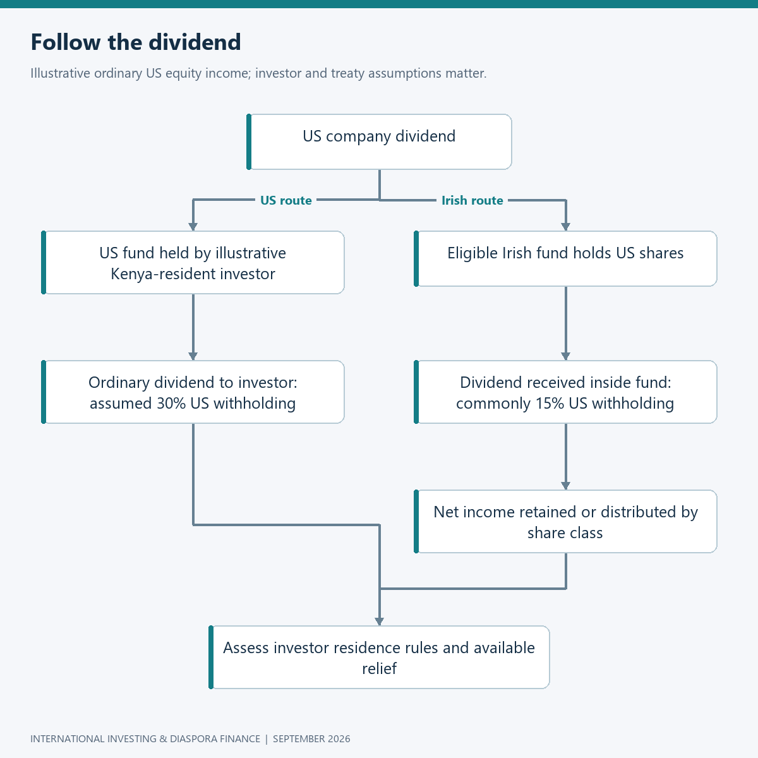
Flowchart: dividend path

Put the saving beside the costs
Consider $100,000 invested in comparable S&P 500 exposure with an assumed gross dividend yield of 1.5%. To illustrate the scale of published operating charges, use VOO’s 0.03% expense ratio and the Irish accumulating fund’s 0.07% ongoing charge [3], [10]. This is a simplified structural comparison, not a forecast of either fund’s tracking performance. Applying withholding and charges independently to the assumed starting portfolio produces annual deductions of $480 on the US route and $295 on the Irish route. The difference is $185, or 0.185% of portfolio value. Actual fund accounting, changing asset values, securities lending, dividend timing, and personal taxes can change the realised comparison. Nevertheless, the arithmetic provides a sensible scale: the Irish structure’s extra four basis points of operating charge can be smaller than its assumed dividend-withholding advantage for this particular investor.

Worked calculation 3 Dividend withholding and operating charges
Approximate annual drag = portfolio × [(gross dividend yield × withholding rate) + fee]
Gross dividends = $100,000 × 0.015 = $1,500
US route withholding = $1,500 × 0.30 = $450
US route operating charge = $100,000 × 0.0003 = $30
US route combined drag = $450 + $30 = $480
Irish route withholding = $1,500 × 0.15 = $225
Irish route operating charge = $100,000 × 0.0007 = $70
Irish route combined drag = $225 + $70 = $295
Difference = $480 − $295 = $185
Difference ÷ portfolio = $185 ÷ $100,000 = 0.00185 = 0.185% = 18.5 basis points
Excluded: personal tax, trading, funding, FX, and other tracking effects.
A break-even calculation makes the comparison more useful than declaring one wrapper the permanent winner. Under exactly the same assumptions, the additional 0.04% operating charge is offset when the gross dividend yield multiplied by the 15-percentage-point withholding difference equals 0.04%. That gives a yield of approximately 0.267%. If Brian personally qualifies for a 15% US treaty rate, however, the assumed withholding gap disappears; the same formula then no longer produces that break-even advantage. Other considerations, including access, reporting treatment, and estate exposure, remain relevant. The lesson is to change the inputs when the investor changes. It is also worth testing fixed costs: an extra $20 annual dealing cost would consume a substantial share of a $37 structural saving on a $20,000 portfolio. A percentage advantage becomes actionable only when compared with the actual size and operating pattern of the account.

Worked calculation 4 Testing the threshold
Break-even yield = additional annual fund fee ÷ withholding-rate difference
= (0.0007 − 0.0003) ÷ (0.30 − 0.15)
= 0.0004 ÷ 0.15 = 0.002666667 = 0.2667%
At a $20,000 balance and the earlier 1.5% yield:
Annual structural saving = $20,000 × 0.00185 = $37
After an assumed extra $20 dealing cost: $37 − $20 = $17
This is a sensitivity test, not a broker fee quotation.
Costs matter over time because money lost to repeated charges also loses the opportunity to participate in future growth. Sharpe’s arithmetic of active management explains the importance of comparing returns after costs within a properly defined market [11]. For household planning, a simple compound-growth illustration makes the effect tangible without pretending to forecast returns. A $10,000 lump sum growing at a hypothetical net 7% for 20 years reaches about $38,697; at 6.5%, it reaches about $35,236. The difference is approximately $3,460. These smooth paths conceal real volatility and assume no contributions, withdrawals, or tax events. They are useful for understanding scale, rather than selecting a future return assumption. Amina should therefore evaluate recurring costs carefully while remembering that earning an extra percentage point is uncertain, whereas an avoidable charge is a concrete feature of the arrangement she chooses.

Worked calculation 5 A recurring half-point difference
Future value = initial capital × (1 + annual net return) raised to the number of years
At 7.0%: $10,000 × 1.07²⁰ = $10,000 × 3.869684462 = $38,696.84
At 6.5%: $10,000 × 1.065²⁰ = $10,000 × 3.523645064 = $35,236.45
Difference = $38,696.84 − $35,236.45 = $3,460.39
Returns are hypothetical, constant, nominal, and already net of the assumed drag.

Accumulation changes the cash flow
An accumulating class retains investment income within the fund, while a distributing class pays income out. That distinction can simplify reinvestment, but it does not itself answer when the investor owes tax. Catherine’s fund can accumulate income while her residence country’s rules still require a taxable event to be recognised; Part 2 examines specific examples. For investment planning, the initial question is what the household intends to do with the income. If every distribution would immediately be reinvested, accumulation can reduce manual decisions and idle cash. If Brian expects the investment to contribute toward regular family support, distributions may be convenient, although their amount and timing may not match the family’s bills. Either way, evaluating total return requires considering both the change in asset value and income paid out. A distribution is part of the investment’s economic return, not a separate bonus detached from the value of the holding.
There is a behavioural dimension to this choice that rarely appears in a fee table. Some investors find visible cash distributions reassuring and consequently maintain a long-term plan more consistently. Others spend whatever arrives and would accumulate more wealth through automatic reinvestment. Neither preference should be mistaken for a universal tax principle. The siblings can test their own habits against the intended use of the account: will a quarterly payment be reinvested, saved for a known expense, or absorbed into ordinary spending? They can also compare the administrative burden of distributions with the record-keeping required for accumulating funds in their actual residence country. The most suitable class is the one that fits both the tax framework and the household’s execution habits. A theoretically elegant investment is less useful if its owner repeatedly handles the cash in a way that undermines the original objective.
Fund performance comparisons require equal care. A price-only index leaves out dividends; a gross total-return index reinvests dividends before assumed withholding; a net total-return index incorporates a withholding convention. Vanguard’s cited factsheet identifies a net benchmark using a 30% dividend-withholding assumption [3]. An apparent excess return relative to such a benchmark can therefore arise partly from a tax convention rather than exceptional stock selection. The investor should compare the same period, currency, and return definition before drawing conclusions. Tracking difference measures the actual gap between fund and benchmark returns; the stated fee is only one influence on that gap. This is particularly relevant when a promotional chart appears to show an index fund consistently beating its index. The first task is to understand what both lines measure, then decide whether the observed difference says anything useful about future implementation costs.

Execution is part of the investment
The next practical issue is the price paid for the shares. Suppose a hypothetical ETF has a bid of $99.90 and an ask of $100.10. Buying 100 shares at the ask costs $10,010 before commission, while immediately selling at the unchanged bid returns $9,990. The $20 difference is the round-trip spread cost. Relative to the $100 midpoint, the quoted spread is 0.20%, while the purchase alone is 0.10% above that midpoint. Distinguishing those figures prevents the common mistake of charging the full round-trip spread to both sides of a cost estimate. Actual prices can move before either order executes. A limit order specifies a maximum purchase price, but may remain unfilled. The point of checking execution conditions is to understand the available trade-off between price and completion, especially when investing smaller amounts across different exchange trading hours.

Worked calculation 6 Spread and purchase cost
Midpoint = ($99.90 + $100.10) ÷ 2 = $100.00
Quoted spread = ($100.10 − $99.90) ÷ $100.00 = 0.002 = 0.20%
Purchase premium to midpoint = ($100.10 − $100.00) ÷ $100.00 = 0.10%
Buy 100 shares = 100 × $100.10 = $10,010
Immediate sale, unchanged quote = 100 × $99.90 = $9,990
Round-trip spread loss = $10,010 − $9,990 = $20, before commissions.
Repeated small decisions can matter more than one carefully optimised fund choice. Barber and Odean’s study of individual brokerage households associated heavy trading with substantially weaker net performance in its historical sample [12]. That evidence concerns a particular market and period, rather than proving that every modern trade is harmful, but it challenges the assumption that constant activity improves results. For Brian, the practical response is a purchase routine and a reason for changing it. New money might be invested on a scheduled basis, with portfolio reviews tied to changes in goals or allocation rather than every market headline. A transaction log can capture the reason for each sale. Looking back, he can distinguish necessary changes from reactions that added friction without advancing his plan. The availability of instant trading is a facility; deciding when to use it remains an investment skill.

Ownership includes what happens later
US estate exposure is another reason the legal structure deserves attention. The IRS states that certain nonresident, noncitizen estates must file Form 706-NA when relevant US-situated assets exceed $60,000, and identifies shares of US-organised corporations among the assets within scope [13]. That threshold is not a rule that automatically confiscates 40% of everything above $60,000. The actual result depends on the estate, deductions, applicable rules, and any relevant treaty. Holding American corporate shares through an overseas brokerage does not by itself change their situs. A genuinely non-US corporate fund share is a different asset from direct ownership of its underlying American shares, which makes fund structure relevant to succession planning. The siblings should identify the legal asset they hold and the jurisdictions involved while their arrangements are manageable, rather than leaving relatives to reconstruct the position later.
The practical estate discussion extends beyond tax rates. Someone should be able to identify the institutions involved, locate ownership records, and understand which professional can help administer the account. That does not mean sharing passwords or creating informal access arrangements that conflict with account terms. It means maintaining a secure asset inventory, appropriate legal instructions, and current contact details. For a diaspora household, the difficulty may be that the person organising the estate lives in a different country from the broker and has never seen the investment documents. A clear folder with account identifiers, statements, and relevant contacts can reduce that burden. Account title also matters: money intended for a parent but held in a child’s personal investment account remains subject to the actual legal arrangement. Describing it within the family as “Mum’s portfolio” does not necessarily establish ownership or succession rights.
US taxpayers require a separate branch of this analysis. An Irish ETF that appears efficient for a non-US investor can raise passive foreign investment company issues for a US person, including Form 8621 reporting and specialised tax treatment [14]. A Kenyan passport does not remove that question if the individual also has relevant US citizenship or tax status. The articles therefore use ordinary non-US investors for the main wrapper comparison and flag a move into US taxation as a reason to revisit the structure before extending the example. This is a substantive limitation of the model, rather than an objection to investing internationally. Amina, Brian, and Catherine can all own the same economic exposure while needing different legal wrappers. Recognising the boundary early allows the analysis to remain useful without turning one household’s solution into a rule for every member of the diaspora.

Turn the research into a repeatable decision
Before adopting an allocation, the family can test a loss that would feel uncomfortable in actual money. A hypothetical 30% decline takes a $10,000 equity holding to $7,000. Recovering the original balance then requires a gain of about 42.86%, because the recovery starts from a smaller base. If the household also withdraws $1,000 after the decline, only $6,000 remains invested and the gain required to reach $10,000 becomes 66.67%. Neither calculation predicts a market crash or its recovery time. It exposes the interaction between volatility and cash demands, which a smooth compound-growth illustration hides. Brian can use the exercise to decide how much family support should already be funded outside equities. A reserve has an opportunity cost when markets rise, but it can protect the household from needing to sell an investment at a time chosen by an urgent bill.

Worked calculation 7 Recovery after a loss and withdrawal
Value after 30% decline = $10,000 × 0.70 = $7,000
Required recovery = ($10,000 ÷ $7,000) − 1 = 42.8571%
After a further $1,000 withdrawal: $7,000 − $1,000 = $6,000
Required recovery from remaining assets = ($10,000 ÷ $6,000) − 1 = 66.6667%
Portfolio maintenance becomes easier when the intended allocation is written down. Suppose a household chooses a hypothetical 70% equity and 30% reserve allocation on $10,000, then equities rise by 20% while the reserve remains unchanged. The account becomes $8,400 of equities and $3,000 of reserve, so equities now represent about 73.7%. Returning to 70% would mean $7,980 in equities, a $420 reduction if done entirely by selling. Alternatively, new reserve contributions can move the allocation toward the target without an immediate equity sale. This calculation does not recommend 70/30 for the siblings; it shows how a chosen policy can generate an intelligible action. Before trading, the household can compare the resulting benefit with taxes and transaction costs. Rebalancing is most useful when it restores a considered risk position, rather than creating activity for its own sake.

Worked calculation 8 Rebalancing after a market move
Equities after gain = $7,000 × 1.20 = $8,400
Total = $8,400 + $3,000 = $11,400
Equity weight = $8,400 ÷ $11,400 = 73.6842%
Target equity amount = $11,400 × 0.70 = $7,980
Illustrative sale to target = $8,400 − $7,980 = $420
Assumes no tax, dealing cost, reserve return, or simultaneous contribution.
The research can now be reduced to a sequence that the siblings can actually repeat. They begin with the purpose and currency of the money, select the underlying exposure, identify the fund’s legal structure and share class, and assess their own tax position. Only then do they compare broker access, funding costs, and the practical purchase. The flowchart below expresses that sequence, with a return to earlier decisions whenever a tax or access issue changes the economics. It also leaves room for a perfectly reasonable conclusion: the proposed investment may need to wait while a cash reserve or expensive debt receives attention. International access widens the menu of investments; it does not determine the correct order of household priorities. A written decision process helps the family use that wider menu with more confidence and less dependence on whichever ticker was discussed most recently.
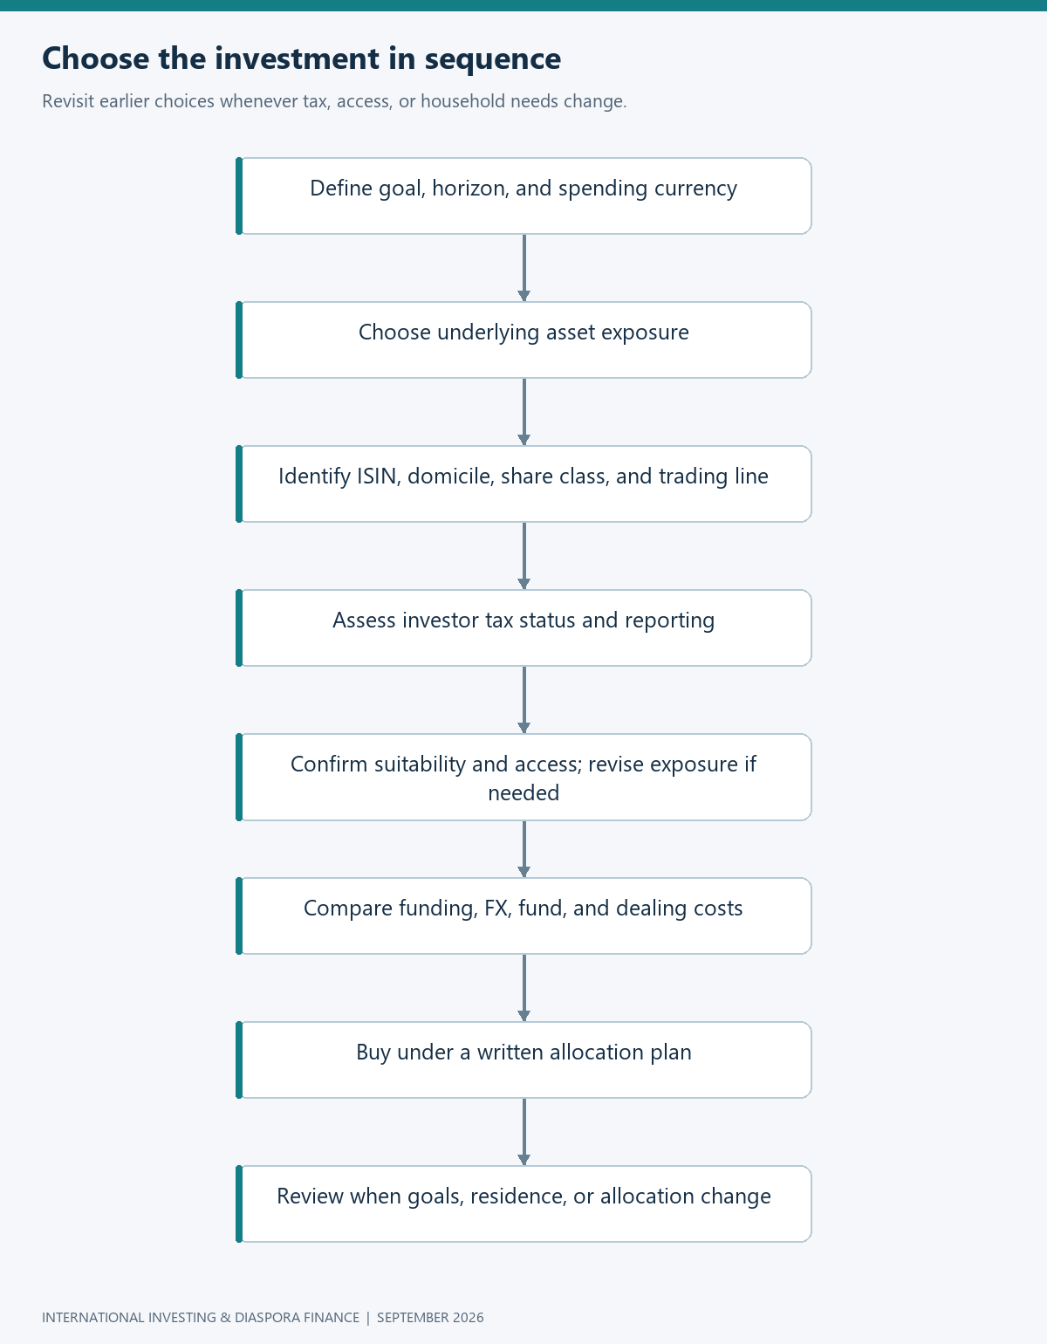
Flowchart: investment decision
By the end of the call, the siblings have a better conversation than the one they started. They can explain what an Irish ETF changes, where dividend withholding enters, why a sterling quote does not settle currency exposure, and how small costs interact with account size. They also know which questions remain personal: residence, reporting, account eligibility, and future relocation. Those questions deserve their own article because the fund can stay exactly the same while the owner’s tax outcome changes. In Part 2, the family follows that change across Kenya, Britain, Ireland, and a German comparison, using residence and taxable-income calculations that can be checked by hand. The aim is to make international investing understandable enough to operate for years. Choosing the investment is the first step; understanding how it fits the investor’s changing life is what makes the choice durable.

References
[1] J. F. Cocco, F. J. Gomes, and P. J. Maenhout, “Consumption and portfolio choice over the life cycle,” The Review of Financial Studies, vol. 18, no. 2, pp. 491–533, 2005, doi: 10.1093/rfs/hhi017.
[2] K. R. French and J. M. Poterba, “Investor diversification and international equity markets,” American Economic Review, vol. 81, no. 2, pp. 222–226, 1991. [Online]. Available: author research record. Accessed: Sep. 7, 2026.
[3] Vanguard, “Vanguard S&P 500 UCITS ETF (USD) Accumulating,” factsheet, Jul. 31, 2026. [Online]. Available: fund factsheet. Accessed: Sep. 7, 2026.
[4] U.S. Securities and Exchange Commission, “Updated investor bulletin: Exchange-traded funds (ETFs),” Feb. 23, 2023. [Online]. Available: Investor.gov bulletin. Accessed: Sep. 7, 2026.
[5] Irish Revenue, “Collective investment vehicles: Funds,” Jun. 30, 2025. [Online]. Available: Revenue guidance. Accessed: Sep. 7, 2026.
[6] Internal Revenue Service, “Publication 515 (2026): Withholding of tax on nonresident aliens and foreign entities,” 2026. [Online]. Available: Publication 515. Accessed: Sep. 7, 2026.
[7] Internal Revenue Service, “United States income tax treaties—A to Z,” n.d. [Online]. Available: treaty list. Accessed: Sep. 7, 2026.
[8] State Street Investment Management, “Considerations for non-US investors: US-domiciled ETFs vs. Irish-domiciled UCITS ETFs,” n.d. [Online]. Available: structural comparison. Accessed: Sep. 7, 2026.
[9] Government of Ireland, “Double Taxation Relief (Taxes on Income and Capital Gains) (United States of America) Order, 1997,” S.I. no. 477/1997, art. 10. [Online]. Available: treaty text. Accessed: Sep. 7, 2026.
[10] Vanguard, “VOO—Vanguard S&P 500 ETF,” expense ratio dated Apr. 28, 2026. [Online]. Available: product profile. Accessed: Sep. 7, 2026.
[11] W. F. Sharpe, “The arithmetic of active management,” Financial Analysts Journal, vol. 47, no. 1, pp. 7–9, 1991. [Online]. Available: author-hosted article. Accessed: Sep. 7, 2026.
[12] B. M. Barber and T. Odean, “Trading is hazardous to your wealth: The common stock investment performance of individual investors,” The Journal of Finance, vol. 55, no. 2, pp. 773–806, 2000, doi: 10.1111/0022-1082.00226.
[13] Internal Revenue Service, “Some nonresidents with U.S. assets must file estate tax returns,” n.d. [Online]. Available: estate guidance. Accessed: Sep. 7, 2026.
[14] Internal Revenue Service, “Instructions for Form 8621,” Dec. 2025. [Online]. Available: PFIC instructions. Accessed: Sep. 7, 2026.

